HEART FAILURE CLINICAL RECORDS.

**MD.SALLAUDDIN**

# Department of Computer Science and artificial Intelligence

# SR University

# Hasanparthy, Hanamkonda, 506371, Telangana

MOOLA HARSHITHA(2203A51430@sru.edu.in)

B.SHIVATHMIKA(2203A51462@sru.edu.in)

P.NITHYA SREE(2203A51508@sru.edu.in)

***Abstract***— **Heart failure (HF) represents a significant burden on healthcare systems worldwide. This study examines clinical records of patients with HF to establish the need for appropriate interventions to clarify demographics by demo, comorbidities, treatment regimen, and output Comorbidities such as hypertension and diabetes commonly affect HF of, affecting disease progression. Various therapeutic strategies have been used, including pharmacologic and surgical interventions, highlighting the complexity of HF management**

**Results research reveals insights into strategies for readmission, mortality, and quality of life to facilitate risk stratification and personalized care planning Overall, this study also highlights the multidimensional appeal of HF to tourists. Reputation Comprehensive strategies for improving patient outcomes.**

1. **INTRODUCTION**

Heart Failure(HF) is the most prevalent health problem across the world requiring immediate attention, affecting hundreds of millions of people, and a major burden on any health care system. That's a chronic condition in which the heart fails to pump enough blood to meet the body’s needs. This can often result in chronic symptoms like fatigue, breathlessness and fluid retention.Despite advances in treatment and management approaches, HF remnants A foremost source Of hospitalization And death, with an elderly population attributed to a higher prevalence and predisposing conditions such as high blood pressure, diabetes and obesity

Understanding the nuances of HF management requires comprehensive analysis of clinical records including patient demographics, comorbidities, treatment modalities, And outcomes Such insights is needed to tailor interventions to the needs of individual patients, optimize resource utilization, and improve overall health care

By analyzing clinical data, including patient profiles, disease course, and treatment response, healthcare professionals can gain valuable insight into real-world HF management, identifying areas of they must be effective, and guide evidence-based decision-making

In this observe, we aim to discover the complexity of HF care via a comprehensive evaluation of medical statistics. Specifically, we will look at the populace structure, the prevalence and effect of comorbid situations, the usage of treatment techniques, and associated outcomes in HF sufferers. By clarifying those factors, we are searching for to aid ongoing efforts aimed toward increasing the satisfactory of care and effects for people with HF.

### II. **LITERATURE SURVEY**

[1] Francesco Nappi:Francisco Nappi’s review on ncRNA-targeted therapy examines ncRNA functions, therapeutic strategies such as antisense oligonucleotides, and clinical trial settings .This highlights the need for new delivery systems to improve treatment efficacy.

[2] San Francicso: Cerono and Chicco's observe in PeerJ Computer Science makes use of ensemble gadget getting to know to discover key predictors of diabetes period from digital health records. This revolutionary approach enhances the knowledge of sickness progression and aids inside the improvement of personalized management strategies.They have used two datasets with machine learning models and average score for diabetes is 0.41

[3] Mateusz de Mezer: In biochemistry, Mateusz de Mezer et al. His research explores the role of SERPINA3 in disease processes. Studies examining its dual nature as a potential stimulus or inhibitor of disease progression shed light on its complex mechanisms and implications for therapeutic targets This comprehensive review contributes to our understanding of SERPINA3 increasing its involvement in health and disease.

[4] Emilie Han: An et al.'s examine inside the Journal of the Renin Angiotenssin AldosteroNe Arrangement examines reniN paths iN reduced ischemic coronary heart failure (HFrEF) patients receiving contemporary-day remedy This have a look at on this single net page gives notion into the dynamics and prognostic significance of renin.They have includes 505HFrEF patients with age 62 years with heart failure and having RASi and MRA.

[5] Leonardo Belfioretti: He article with the aid of Belfioretti and friends inside the Journal of Clinical Medicine charts the evolution of cardiovascular tumor manage over a decade, reflecting the development and enjoy of a multidisciplinary crew-based method in a single vicinity offering treasured insights into enhancing affected person care techniques.The study observed reduction among CS patients from 57%-29% between 2012 and 2021.

[6] claudio Stefano Centorbi: Sentorbi and pals' opinion monetary destroy in "New Insights into Cardiomyopathy" clarifies positioned up-COVID-related malignancies of cardiomyopathy, which encompass definitions, clinical settings, evaluation, and control strategies which embody This provides important insights to prevent the extended-time period results of COVID in coronary core -19 infection.

The observation says that the people who are not hospitalized faced heart problems and highlighting need to consider post-COVID in future.

[7] Ștefania-Teodora Duca: Duca et al.'s observein Medicina examines the connection among ischemic coronary coronary heart myopathy, non-cardiac comorbidities, and ECG Holter limitations in affected role with persistent coronary coronary heart failure, providing us with a robust correlation that predicts the coronary coronary heart hobby and prediction.The study includes 60 heart failure patients with ischemic etiology and LVEF<50%,age between 55-77 years with common like diabetes,chronic disease and obesity.

[8] Rumana Anjum: The literature evaluation examines the capability to anticipate cardiovascular hazard using retinal eye photograph assessment, imparting insights into new techniques to cardiovascular ailment chance assessment.

[9] Julie Sochalski: This literature evaluate examines powerful techniques for being concerned for sufferers with coronary coronary coronary heart failure, specializing in their insights into key contributing factors (Sochalski et al., 2009).

**III. PROPOSED APPROACH**

**overview:** Clinical records of heart failure play an important role in health care, contributing to diagnosis and treatment planning. Logistic regression stands out among classification methods because of its effectiveness in predicting cardiovascular risk based on patient data. Although Support Vector Machine (SVM) classification provides robust performance, logistic regression excels in handling the two outcomes, making it ideal for identifying patients at risk for heart failure Simplicity in analysis of cardiac clinical records despite other methods such as multilevel perceptron, naive Bayes, . XGBoost, LightGBM, decision trees and attributes of the Logistic regression is the preferred method for complete heart failure anaylsis.

**Data preprocessing:**

Data preprocessing for cardiac sanatorium report analysis, 0 values replaced with ’zero’ using the fill nan() function. The goal variable ’Dataset’ is separated from the ’y’ variable, while for feature choice, the items are stored in ’x’ except for the ’Dataset’ column. The synthetic minority oversampling method (SMOTE) is then applied to cope with the elegance imbalance. By interpolating between the chosen instances and their nearest buddies in this technique, the process is repeated till the desired equilibrium role is reached or a particular range of artificial observations is made SMOTE ensures that the information set is balanced, for the overall performance of gadget learning fashions will increase in appropriately classifying cardiac effects.

Dataset: The dataset obtained from Kaggle for this assignment consists of 300 rows and thirteen columns.

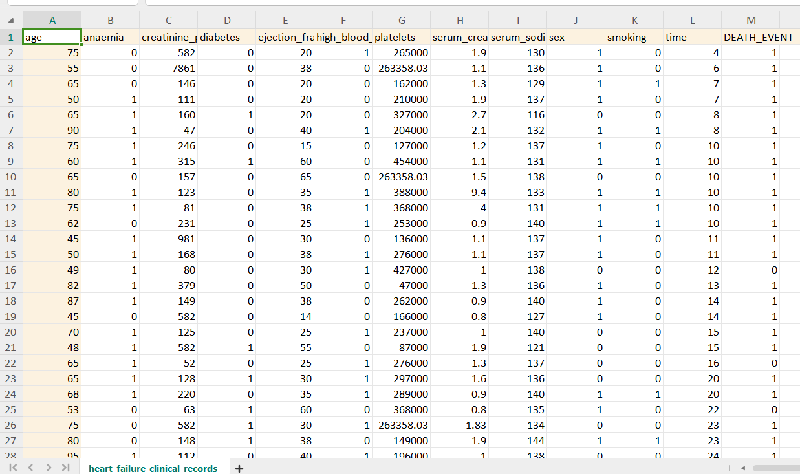

**4. Methodology**

Machine learning models were used to predict cardiac outcomes based on patient data in shared cardiac records.

In This education, a new classification method grounded On user behavior was planned in order To enhance search performance. This approach used user behavior to represent the nature of such information, which is considered more credible for crime-related information. Content included author and reader behavior, with a total of ten items extracted per entry, of which seven were author-related and three were reader-related

Six great tool studying algorithms have been used for sophistication competencies: multilevel perceptron, naive Bayes, XGBoost, LightGBM, desire wood, logistic regression Each of those models have become evaluated based totally on their regular widespread performance metrics to decide an effective method than to assume coronary coronary coronary coronary heart failure in scientific data. However, logistic regression stays the approach of choice for whole coronary coronary coronary coronary coronary heart contamination assessment due to its simplicity and interpretability in dealing with effects

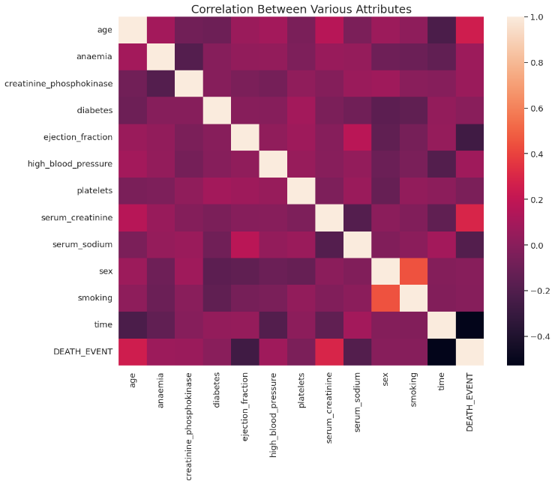

* **Logistic Regression:**

Logistic Regression is a mathematical approach for second category capabilities, wherein the consequence adjustable can tackle only feasible values, usually coded as zero and 1. It is a dating among one or more variables an example of a greater suggested relationship between itself than it's miles for a particular final results.

This feature can estimate the chance that a given enter belongs to one of the two corporations Model parameters are envisioned the use of most likelihood estimation, typically the use of optimization algorithms such as gradient descent

Logistic regression is broadly used in industries which include finance, healthcare, and advertising for obligations such as patron churn forecasting, spam electronic mail classification, and scientific analysis.

After becoming a logistic regression model to cardiac registry data, accuracy is often used as a metric to evaluate its performance Accuracy measures the exceptional anticipated outcome (i.E., whether the affected person had a coronary heart attack or no longer he does now not have one) while in comparison to the overall variety of patients inside the facts set. Accuracy changed into done, i.E. It correctly labeled 80% of the patients’ cardiac repute based on the scientific characteristics of the database

Despite its linear nature, logistic regression is able to take care of complex relationships thru feature engineering interaction phrases. Moreover, it is sturdy towards noise and records loss. However, logistic regression can conflict with nonlinear relationships and might not carry out well on especially imbalanced information sets.

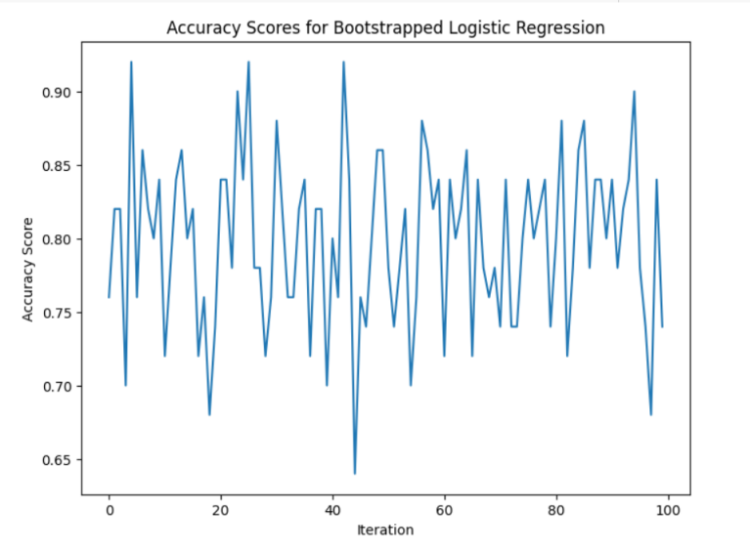

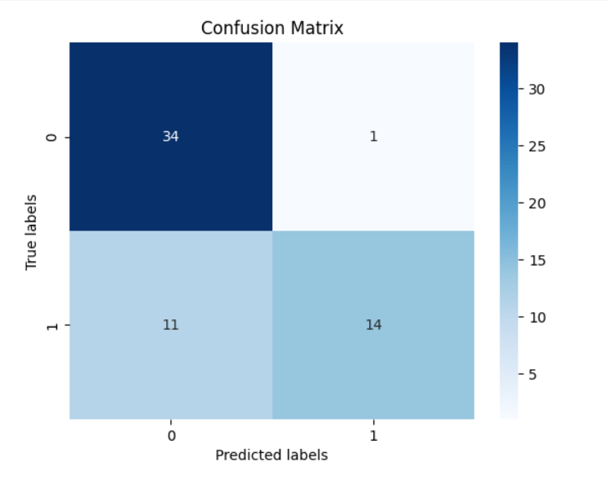

* **SVM:**

Support vector device (SVM) category is a supervised getting to know set of rules used for binary multiclass class tasks. SVM works with the aid of finding the high-quality hyperplane that pleasant separates the training inside the feature area.Support Vector Machine (SVM) classification is a supervised mastering set of rules used for binary multiclass category responsibilities. SVM works by means of finding the satisfactory hyperplane that nice separates the lessons in the feature space.

It ambitions to maximise interclass comparison, that is the distance among the hyperplane from each elegance and neighboring facts points, and thus improve the normalization of unseen facts SVM can take care of linear and nonlinear class tasks managed through kernels that switch information in a high-dimensional manner . Common kernel capabilities for acquiring selection bounds consist of linear, polynomial, and radial basis features (RBF).

SVM works properly for excessive-dimensional records units and is hardly overfitted, making it appropriate for a number of applications together with photo recognition, text type, bioinformatics, etc. But the computational demanding situations of SVM are statistics-. His group grows to length

SVM classifiers have several blessings, consisting of its effectiveness in processing huge-dimensional statistics sets, and effectiveness in processing nonlinearly separable data and SVM tends to generalize properly to others to maximise the margin between training, reducing danger **with** records overfitting Provides flexibility in records class, making it extra flexible.

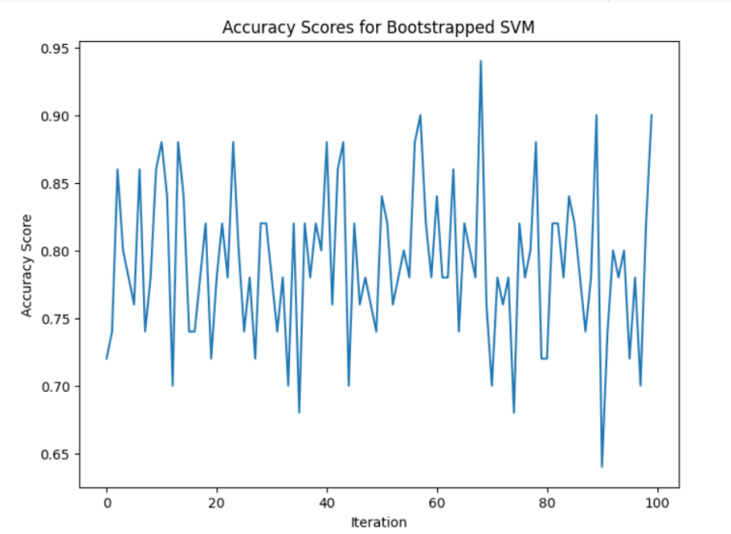

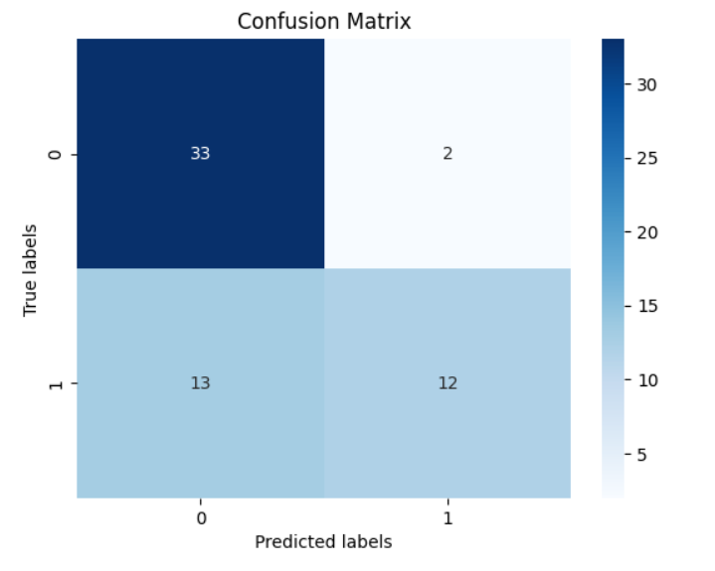

* **Decision Tree**

Decision timber are a flexible supervisory getting to know algorithm for type and regression duties. The feature space is divided right into a tree-like structure, wherein every internal node represents an characteristic or function, and every leaf node represents a category label or numeric fee The choice method starts at the basis node and continues on bottom tree based totally on value.

The selection tree production involves iteratively splitting the statistics set into subsets primarily based on the function that satisfactory separates the information, ensuing in branches representing one of a kind choice strategies Separation standards are chosen to assign (for partitioning); or reduced (for) the variance in every class Regression). Common classifications include Gini purity, entropy, and suggest squared blunders.

Decision timber provide many benefits, which includes their interpretation, because the ensuing tree shape is easy to see and understand. Both statistical and categorical statistics can be processed without the need for preprocessing. Decision timber are also sturdy to outsiders and can automate choices by figuring out informative functions for prediction.

However, decision timber may be overfitting, especially while deep or whilst the dataset is noisy. Strategies which includes pruning trees, restricting the depth of the tree, or setting the minimal number of samples had to classify nodes can help to lessen over-constraint Furthermore, the choice bushes sensitive to small modifications in training facts, that may cause exceptional tree structures for the identical data set.

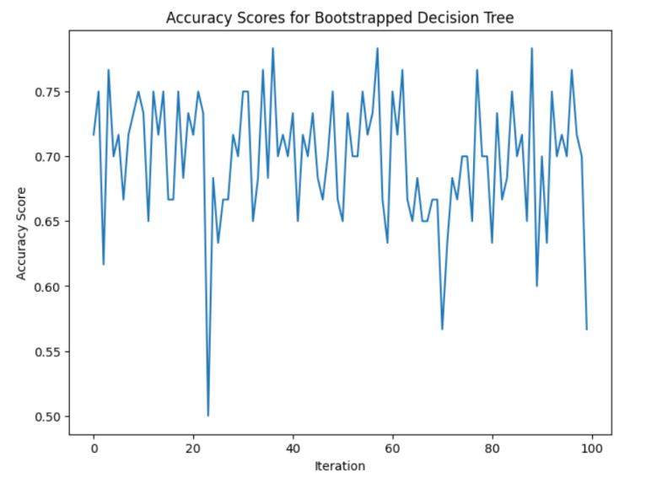

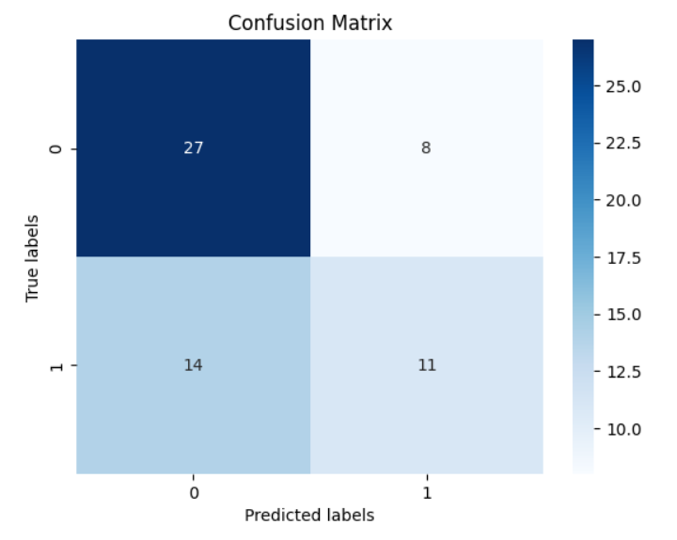

* **XGB Boost**

In classification applications, XGBoost, or Extreme Gradient Boosting, offers impressive capabilities, especially with the regularization method embedded in the objective function These methods include L1 (Lasso) and L2 (Ridge) regularization steps, and so on XGBoost removes greater model complexity -Allows you to control efficiently During training. This control tool is particularly useful in classification situations characterized by noisy or large data.In classification applications, XGBoost, or Extreme Gradient Boosting, offers impressive capabilities, especially with the regularization method embedded in the objective function These methods include L1 (Lasso) and L2 (Ridge) regularization steps, and so on XGBoost removes greater model complexity -Allows you to control efficiently During training. This control tool is particularly useful in classification situations characterized by noisy or large data.

By combining L1 and L2 regularizations, XGBoost prevents overfitting by penalizing models that are too complex. Overfitting occurs when a model considers sound or outliers in tHe exercise facts, resultant in poor generalization to the unseen data. The regular use of XGBoost balances the algorithm to better fit the training data and remain smooth, thus increasing its ability to generalize to new models

In classification tasks, where the objective is to accurately classify samples into predefined groups, preventing overfeeding is critical. The XGBoost regularization methods play an important role in achieving this by promoting smooth decision boundaries in the feature space, which helps to reduce the effect of noise and improves the robustness of the model

Additionally, regular XGBoost actually simplifies feature selection by giving less weight to irrelevant or irrelevant features, thus focusing the image on more informative features.

Overall, the XGBoost regularization methods are a powerful tool for the classification task, providing improved normalization performance, robustness to noise, and automatic

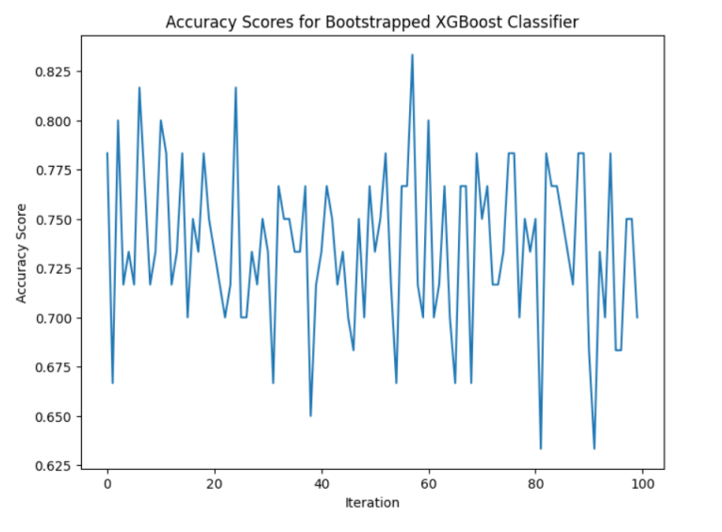

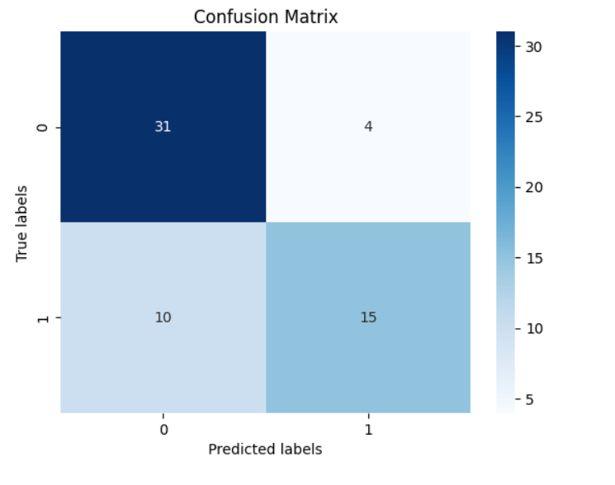

* **Light GBM**

LightGBM is a popular gradient-enhancement framework in machine learning due to its efficiency, speed, and high performance. LightGBM, developed by Microsoft, stands out for its ability to process large amounts of data and complex images with incredible speed and accuracy.

The key feature of LightGBM is its leaf-wise tree-tree structure, which differs from traditional layer-wise tree-tree approaches. By growing trees in leaves, LightGBM can achieve greater accuracy with less memory and more computational resources. This approach focuses on tree minimizing missing functions, resulting in faster and more efficient communication

In addition, LightGBM includes several optimization techniques such as histogram-based algorithms for binning continuous features, which accelerates training speed by reducing computational cost It also supports distributed training, which provides efficient parallelization of devices or cores of many kinds, which is extremely Enables distributed computing and is environmentally friendly

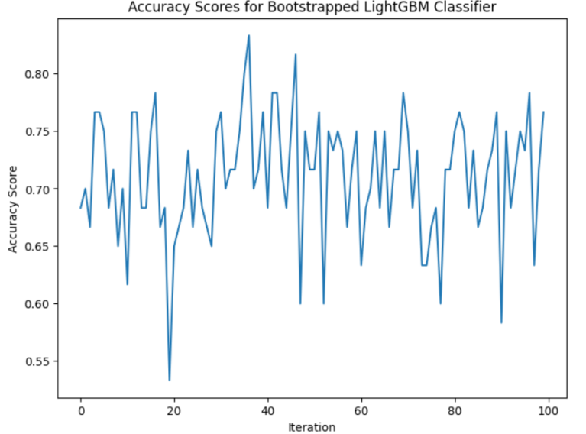

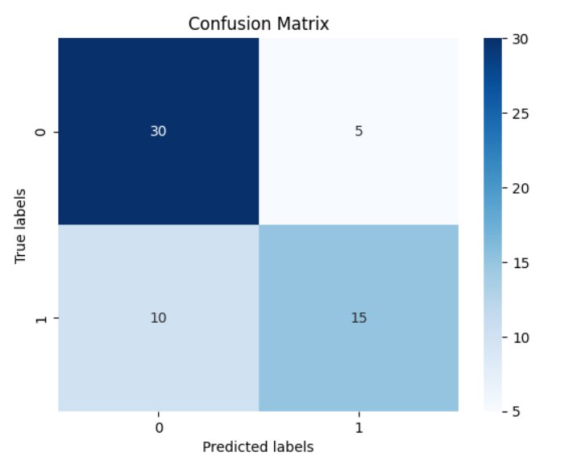

* **Naive Bayes**

Naive Bayes is a well-known set of regulations in machine studying for kind obligations. It’s based totally totally absolutely totally on Bayes’ theorem, which calculates the opportunity of a speculation given the proof. Despite its simplicity, Naive Bayes regularly plays remarkably well, in particular in text type and direct mail filtering. -The ”naive” trouble of Naive Bayes comes from its assumption of independence amongst talents.

It assumes that every function contributes independently to the threat of a particular very last outcomes, which won't maintain actual in real international scenarios. However, this simplifying assumption allows for fast training and prediction, making Naive Bayes mainly useful for huge datasets. -Naive Bayes works with the resource of calculating the possibility of every elegance given the input capabilities and selecting the elegance with the very excellent opportunity as the prediction. Despite its ”naive” assumptions, Naive Bayes may be distinctly powerful and is extensively applied in numerous programs because of its simplicity, efficiency, and frequently aggressive average performance.

Naive Bayes makes use of Bayes’ theorem to estimate the probability that any class given a set of enter attributes:

Despite its simplicity and the unrealistic assumption of feature independence, naive Bayes has a unethical to perform specially nicely in exercise, especially in text beauty obligations in which the concept of independence can pretty well keep

There are numerous styles of naive Bayes, such as Gaussian Naive Bayes, Multinomial NB, and Bernoulli Naive bayes, each of which is appropriate for exclusive classifications of records the usage of Naive-Bayes for continuous functions, Multinomial Naive Bayes for features discrete, and Bernoulli Naive Bayes for two-dimensional components.

In precis, Naive Bayes is a simple but powerful set of rules for classification responsibilities, and its velocity, simplicity, and exceptional accurate performance make it a treasured tool in machine studying device, mainly in scenarios with few statistical features in high-dimensional information.

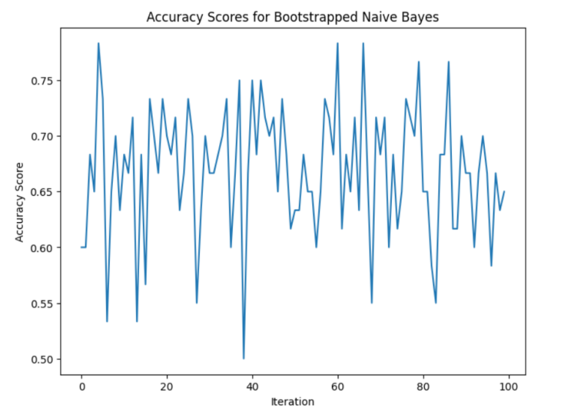

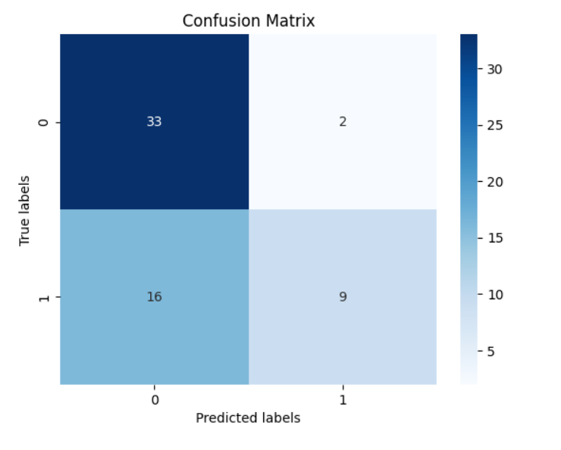

* **MultiLayer Perceptron**

Multilayer perceptron (MLP) is an synthetic neural network with many interconnected layers, organized in a hierarchy MLP is considerably carried out in gadget learning for numerous duties together with class, regression pass, pattern reputation

Every intermediate neuron, except one within the enter layer, is attached to each neuron in the adjacent layer. Correlations among neurons are correlated with weights, and modifications are made at some stage in training to reduce the mistake among predictions and actual outcomes.

Estimation in MLP consists of three main steps: feedforward propagation, backpropagation, and weight updating. In feedforward propagation, input data is passed through the grid, activations are computed layer by layer until the output layer produces a prediction and then backpropagation is used to compute error gradients relative to the weights in the grid.

MLPs are capable of recognizing complex nonlinear relationships in data, and because complex decision boundaries can be modeled by a wide variety of compositional activation functions, some of the most commonly used initiation roles in MLPs are sigmoidal tanh, and advanced linear units ( . ReLU) are available, each of which separately offers the property of computational efficiency and gradient stability

However, MLPs have some limitations, such as potential overloading, sensitivity to extreme parameter selection, and computational complexity, especially for large networks and data types, despite these challenges However, MLPs have some limitations, such as potential overloading, sensitivity to extreme parameter selection, and computational complexity, especially for large networks and data types, despite these challenges

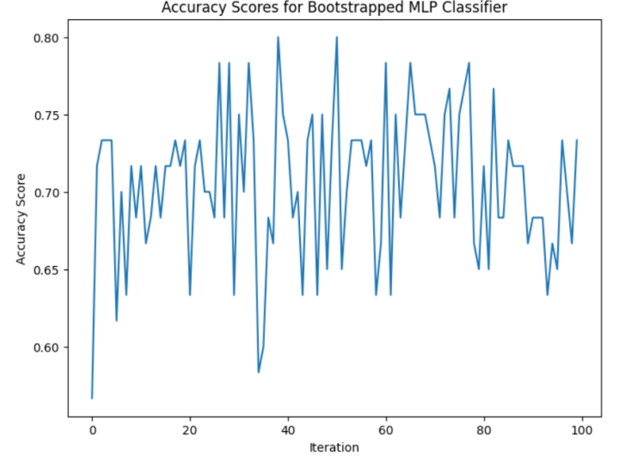

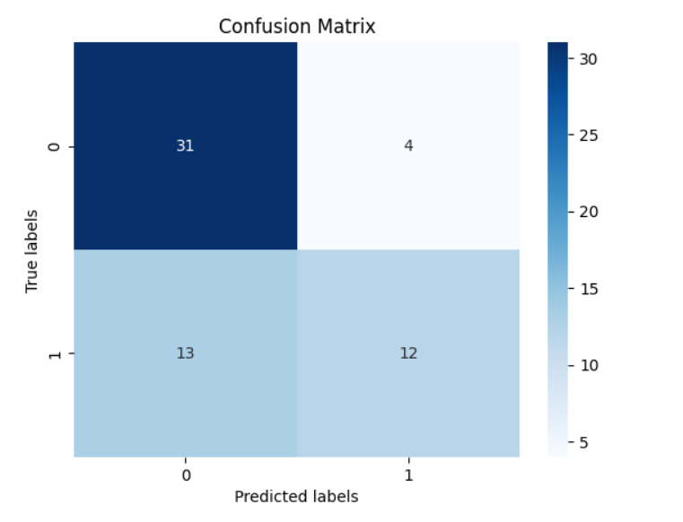

**Result:**

* Logistic Regression:

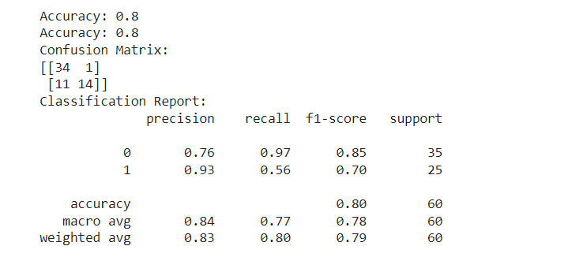

* SVM

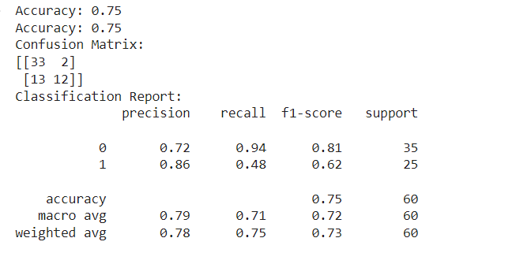

* Decision Tree

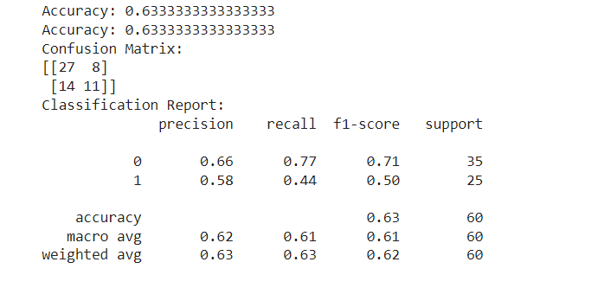

* XGB Boost

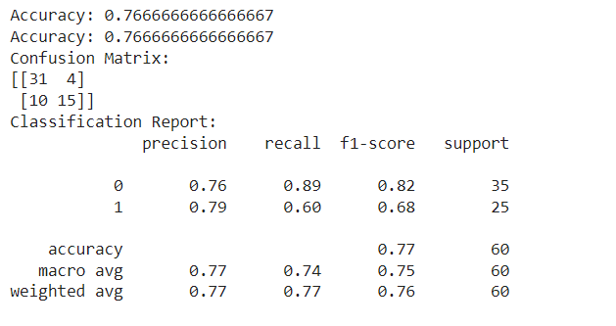

* Light GBM

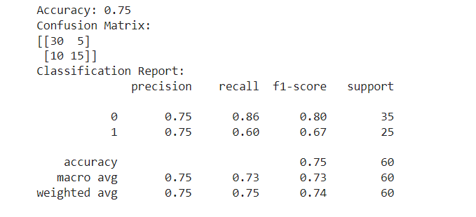

* Naïve Bayes

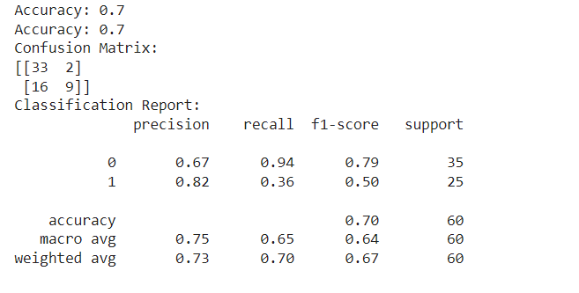

* MultiLayer Perceptron

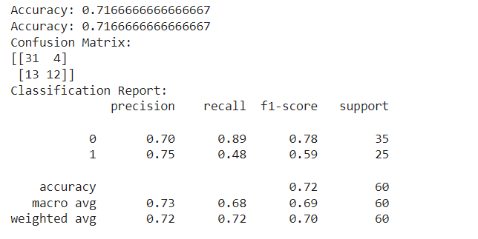

* Overall graph

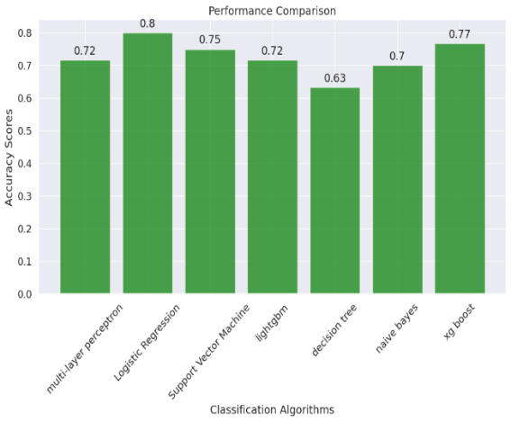

**ACCURACY SCORES:**

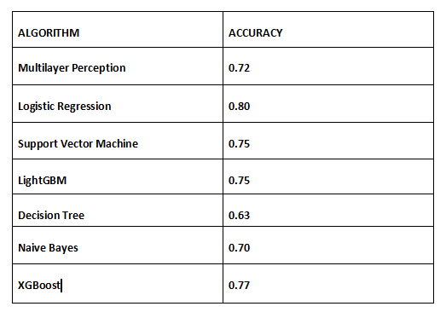

**CLASSIFICATION REPORT(MACRO AVERAGES)**

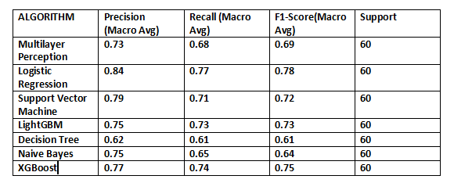

**CONFUSION MATRICES**

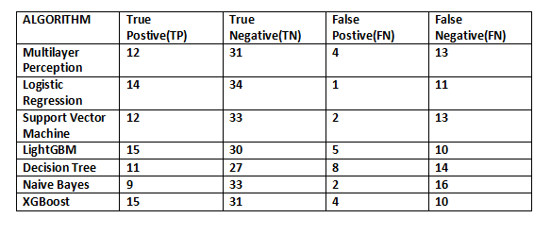

**DETAILED CLASSIFICATION REPORT(WEIGHTED AVERAGES)**

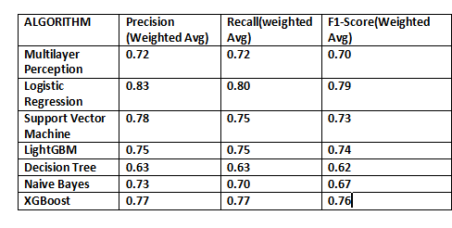

**OVERALL GRAPH VALUES:**

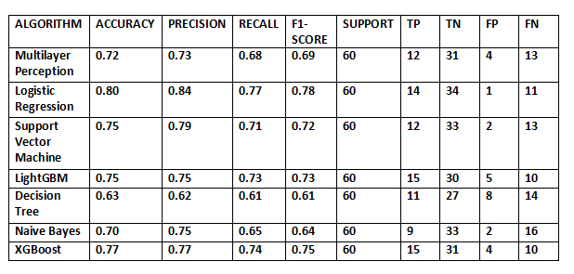

**Conclusion:**

Based on the accuracy scores obtained for each algorithm, logistic regression and XGBoost emerge as the best performing models for heart failure classification Logistic regression achieved an accuracy of 80 percent, while XGBoost achieved an accuracy of 77 percent. These results show that both logistic regression and XGBoost are effective in accurately classifying cardiac arrest data based on clinical records and are therefore recommended as suitable methods for cardiac arrest classification tasks due to their robust performance and high accuracy rates

**REFRENCES:**

**Francesco Nappi, Non-Coding RNA-Targeted Therapy: A State-of-the-Art Review, International Journal of Molecular Sciences, 10.3390/ijms25073630, 25, 7, (3630), (2024).**

**Gabriel Cerono, Davide Chicco, Ensemble machine learning reveals key features for diabetes duration from electronic health records, PeerJ Computer Science, 10.7717/peerj-cs.1896, 10, (e1896), (2024).**

**Mateusz de Mezer, Jan Rogaliński, Stanisław Przewoźny, Michał Chojnicki, Leszek Niepolski, Magdalena Sobieska, Agnieszka Przystańska, SERPINA3: Stimulator or Inhibitor of Pathological Changes, Biomedicines, 10.3390/biomedicines11010156, 11, 1, (156), (2023).**

**Emilie Han, Suriya Prausmüller, Annika Weidenhammer, Georg Spinka, Henrike Arfsten, Philipp E. Bartko, Georg Goliasch, Martin Hulsmann, Noemi Pavo, Renin Trajectories and Outcome in Stable Heart Failure with Reduced Ejection Fraction (HFrEF) on Contemporary Therapy: A Monocentric Study from an Austrian Tertiary Hospital Outpatient Clinic, Journal of the Renin-Angiotensin-Aldosterone System, 10.1155/2023/8883145, 2023, (2025).**

**Leonardo Belfioretti, Matteo Francioni, Ilaria Battistoni, Luca Angelini, Maria Vittoria Matassini, Giulia Pongetti, Matilda Shkoza, Luca Piangerelli, Tommaso Piva, Elisa Nicolini, Alessandro Maolo, Andi Muçaj, Paolo Compagnucci, Christopher Munch, Antonio Dello Russo, Marco Di Eusanio, Marco Marini, Evolution of Cardiogenic Shock Management and Development of a Multidisciplinary Team-Based Approach: Ten Years Experience of a Single Center, Journal of Clinical Medicine, 10.3390/jcm13072101, 13, 7, (2101), (2024).**

**Claudio Stefano Centorbi, Enrica Garau, Leonardo Borsi, Valerio Brambilla, Lorenzo Brambilla, Davide Lazzeroni, Perspective Chapter: Cardiovascular Post-Acute COVID-19 Syndrome – Definition, Clinical Scenarios, Diagnosis, and Management, New Insights on Cardiomyopathy, 10.5772/intechopen.109292, (2024).**

**Ștefania-Teodora Duca, Minerva Codruta Badescu, Alexandru-Dan Costache, Adriana Chetran, Radu Ștefan Miftode, Ionuț Tudorancea, Ovidiu Mitu, Irina Afrăsânie, Radu-George Ciorap, Ionela-Lăcrămioara Șerban, D. Robert Pavăl, Bianca Dmour, Maria-Ruxandra Cepoi, Irina-Iuliana Costache-Enache, Harmony in Chaos: Deciphering the Influence of Ischemic Cardiomyopathy and Non-Cardiac Comorbidities on Holter ECG Parameters in Chronic Heart Failure Patients: A Pilot Study, Medicina, 10.3390/medicina60020342, 60, 2, (342), (2024).**

**undefined Rumana Anjum, undefined Abdul Mohiyuddin, undefined Girisha S, undefined Manupriya B Patil, undefined Nandish DS, Survey on Predicting the Risk of Heart Attack Through Retinal Eye Images Analysis, International Journal of Advanced Research in Science, Communication and Technology, 10.48175/IJARSCT-17589, (545-546), (2024).**

**Julie Sochalski, Tiny Jaarsma, Harlan M. Krumholz, Ann Laramee, John J.V. McMurray, Mary D. Naylor, Michael W. Rich, Barbara Riegel and Simon Stewart What Works In Chronic Care Management: The Case Of Heart Failure Health Affairs, 28, no.1 (2009):179-189**

**doi: 10.1377/hlthaff.28.1.179**